eCMS MANUAL
s

Operational Report

Department of Revenue and Customs
Ministry of Finance
Table of Contents
1. Introduction 1
2. Operational Report 1

Introduction

The report is part of the application submission throughout, the report gives the overall view of the application in a glance by providing parameter. This document illustrates the overall report that can be generated in the eCMS system.

Operational Report
- Below is the list of operational reports that can be generated:

  - Details of Exemption and Tax Foregone
  - Authorized compliance trader approver and validity
  - Number of Application submitted.
  - Number of Registration submitted.
  - Top 10 Commodities Export
  - Top 10 Commodities Import
  - Uncleared Manifest
  - Air Cargo manifest
  - Number of employee(user) registered.
  - Top 10 Importer
  - Top 10 Exporter
  - Role based report.
  - Road manifest
  - Number of Detention/Seizure/Confiscation
  - Number of Duty-Free Quota issued
  - Air passenger Manifests
  - Summary of conveyance entered/exited
  - Summary of Declaration Types Submitted to Customs
  - Temporary Admission reconciliation report
  - Re-export reconciliation Report
  - Refund Exemption reconciliation report
  - Bonded Warehouse Reconciliation Report
  - Details of Goods stored in Each warehouse
  - Details of goods cleared and dispatched from LTO
  - Total number of customs officers by region and check post
  - Total Amount Paid by tax types
  - Expenses incurred to clear the goods from Kolkata

- To generate report, Click on each module:
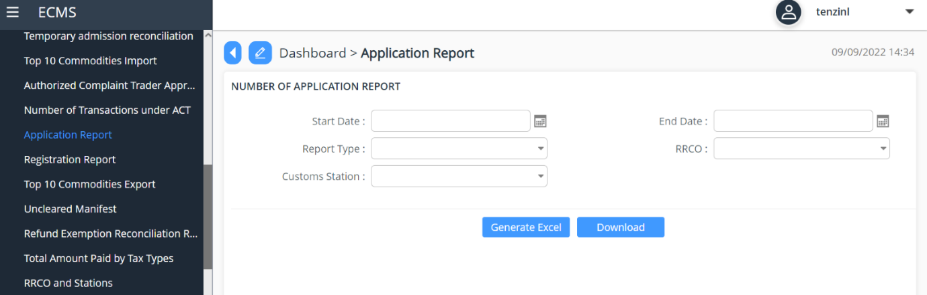

- Input parameters as per the requirement and Click on Generate / Download
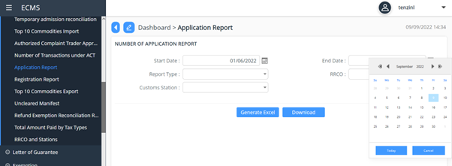
- Finally generate the report (either in pdf or excel).

